Agility

Design Document

Scrum Master: Matthew Newman

Team Members: Matthew Greco, Christopher Myers, Stephen Canzanese, Jerico Alcon

**Details of Planned Pages**

When appropriate, a “Back” button is provided, which navigates to the previous page when selected. Additionally, a “User Home” button is provided, which navigates to the User Page. When the “Sign Out” button is selected, the user is signed out and is navigated to the Sign-in Page. These buttons are only offered when it makes sense to do so.

**Sign-in Page**

This is the Sign-in Page for Agility. It includes text fields for the user to input the email address and password associated with their account. There is also a “Sign in” button which, if the email/password combination is correct for an account, navigates to the User Page. There is also a “Create Account” button if the user does not yet have an account, navigates to the Create Account Page.

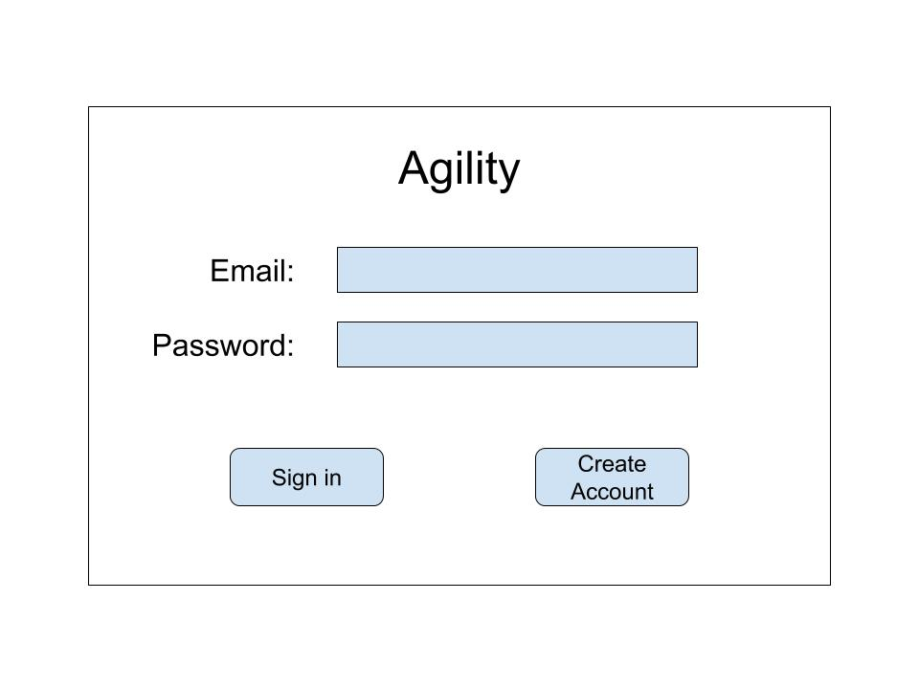

Website endpoints and correlating database tables used by Sign-in Page:

* User table

**Account-Creation Page**

If the user selects the “Create Account” button on the sign-in page, then they are brought to the Account-Creation Page. Here, they enter information for their name, email, and password (which they must enter a second time to confirm). Upon filling out all the information, the user selects the “Create Account” button, which creates the account and navigates to their User Page.

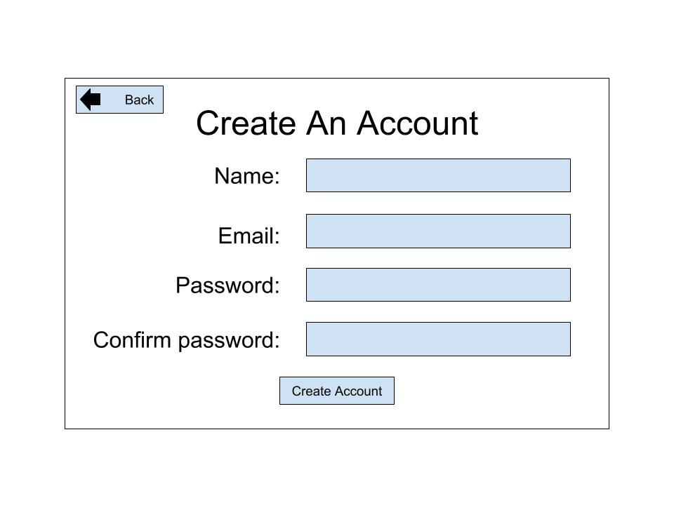

Website endpoints and correlating database tables used by Account-Creation Page:

* User table

**User Page**

The User Page is the “home” page for the user. Here they can view the projects associated with their account, and are provided the ability to create a new project. If they select the button for a given project, then they are taken to the corresponding Project Page for that project. If the “+” button is selected, then a new project is created.

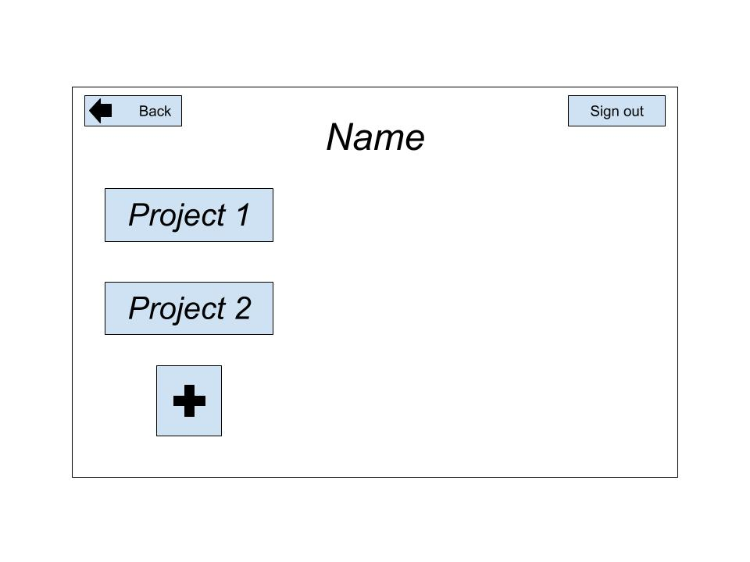

Website endpoints and correlating database tables used by User Page:

* User table
* Role table
* Project table

Buttons and corresponding tables:

* Project button: Project Table

**Project Page**

The project page serves as the “home” page for the project. The project name, summary, and expected beginning and end date is displayed. It also provides the user with a “Sprint Management” button (which navigates to the Sprint Management Page), a “Current Sprint” button (which navigates to the page of the current sprint), a button for any link the team desires (such as for the project Github), and a “Team Page” button, which navigates to the Team Page for the project.. The team is also able to add an image (such as a burnup chart), and the overall velocity of the project is displayed.

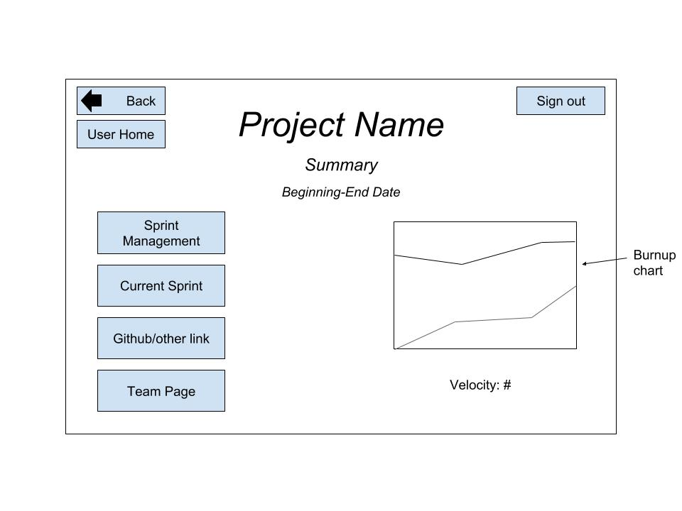

Website endpoints and correlating database tables used by Project Page:

* Project table
* Sprint table
* User_stories table
* Role table
* Team table

Buttons and corresponding tables:

* User Button: User table
* Sprint Management Button: Project table, Sprint table
* Current Sprint Button: Project table, Sprint table
* Github link Button: Project table
* Team Page Button: Project table, Team table

**Sprint Management Page**

The Sprint Management Page presents to the user buttons to navigate to each Sprint page, and also provides the ability for the user to create a new sprint. A scrollable version of the product backlog is presented on the left-hand side of the screen, and allows the user to drag and drop backlog items into a specified sprint. If a button for a sprint is selected, then it navigates to the Sprint page for the corresponding sprint. If the “+” button is selected, then a new sprint is created.

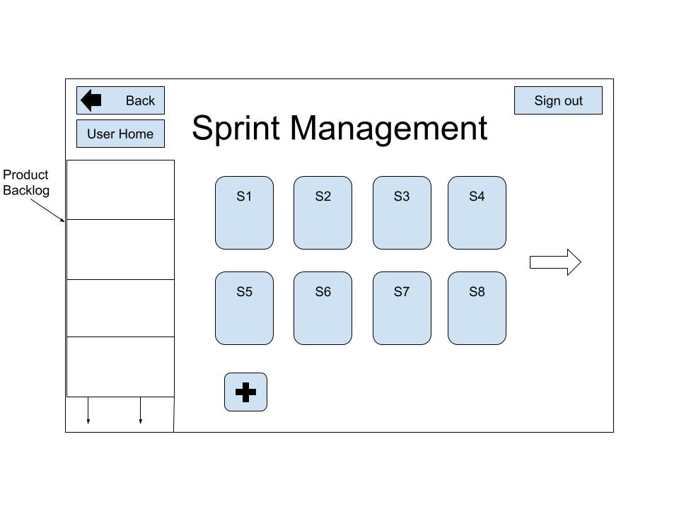

Website endpoints and correlating database tables used by Sprint Management Page:

* Project table
* Sprint table
* User_stories table
* Role table
* Team table
* User table
* Requirements table
* To_do table

Buttons and corresponding tables:

* User Button: User table
* Product Backlog Bar: User table, To_do table, Requirements table, Project table, Role table, User_Stories table
* Sprint Buttons: User_Stories table, Sprint table, Team table

**Sprint Page**

The Sprint Page is the main page for a Sprint. It shows four scrollable lists of backlog items: Product Backlog, To-do, In Progress, and Done. Functionality is provided for the user to drag and drop backlog items between the lists. A “Sprint Review” button is provided, and when selected, triggers a pop-up window containing an editable text file. There is also a “Sprint Retrospective” button that triggers a pop-up window containing an editable text file when selected. The heading of the page displays the current sprint number, and the user is given the ability to click on the heading to open a drop-down box to easily switch between sprints pages.

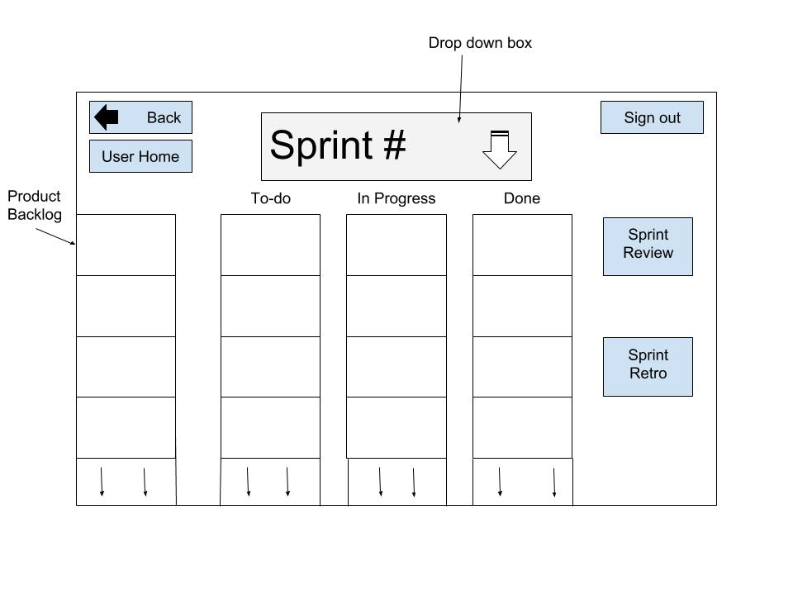

Website endpoints and correlating database tables used by Sprint Page:

* Project table
* Sprint table
* User_stories table
* Role table
* Team table
* User table
* Requirements table
* To_do table

Buttons and corresponding tables:

* User Button: User table
* Sprint Bar: Sprint table, team table
* Product Backlog Bar: User table, To_do table, Requirements table, Project table, Role table, User_Stories table
* Sprint Review Button: Sprint table, Project table
* Sprint Retro Button: Sprint table, Project table

**Team Page**

The Team Page displays a scrollable list of all the team members for the project. For each member, their picture, team role, name, and email are presented.

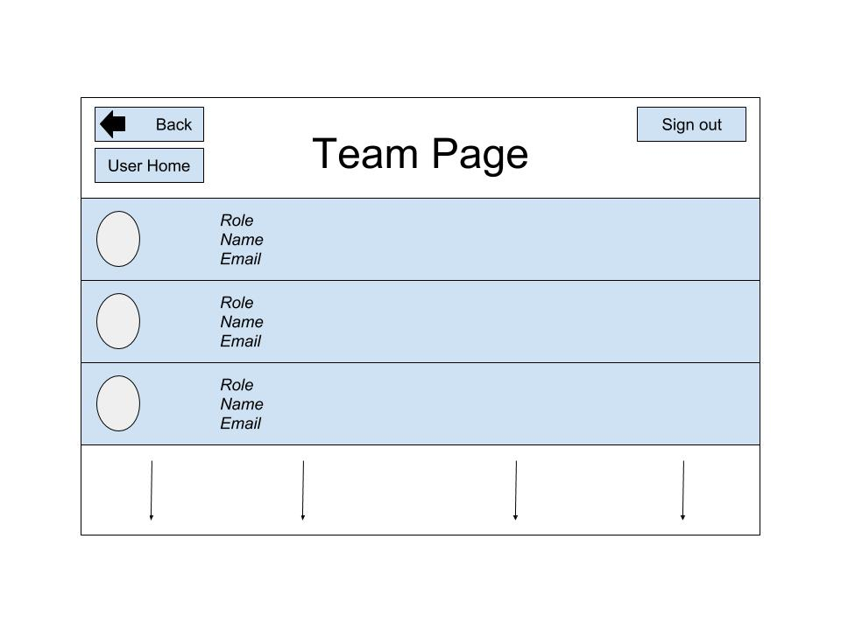

Website endpoints and correlating database tables used by Team Page:

* User table
* Role table
* Project table
* Team table
* Sprint table
* User_stories table

**EER Diagram**

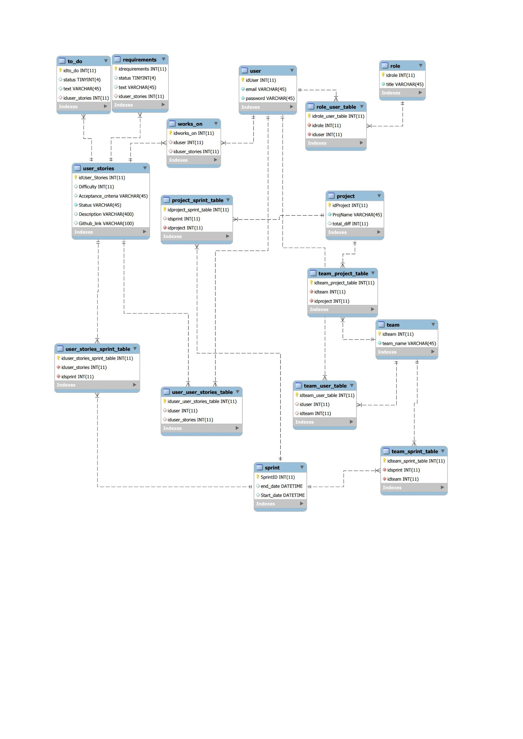

**Classes planned to be used**

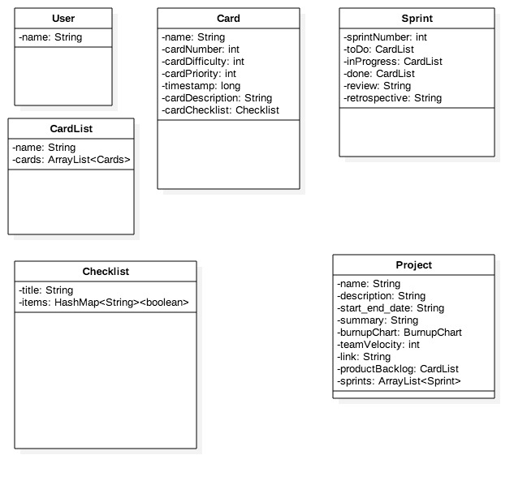

**Prototype**

For the prototype, we plan on having three working pages: the Sign-in Page, the Account-Creation Page, and the User Page. We want the user to be able to sign in with their email/password combination, which will bring them to the User Page. If they do not yet have an account, then they will be able to navigate to the Account-Creation Page. Once their details are filled out, then their account is created and they are navigated to the User Page. Additionally, we want to demonstrate how the burnup chart generation will work.

A concern we have is how we aim to develop the burnup chart. We are not yet sure how we will handle the automatic generation of the burnup chart for a project based on the backlog items completed versus those yet to be completed. Additionally, we are not entirely positive on how exactly we will handle the accounts (email/password combinations).

We aim to address the burnup chart concern by creating a separate prototype in which a burnup chart is automatically created based on the values input. Through this, we will demonstrate an understanding on how this feature of Agility will function. For the account concern, we aim to further research how to implement an account system, and apply what we learned to Agility.